CREATE TABLE DELIVERYMAN_DETAILS

(

NAME varchar(20),

Email varchar (20),

phone int(11),

Delivery_no int(100),

PRIMARY KEY(NAME)

);

INSERT INTO deliveryman_details

(NAME,Email,Phone,Delivery_no)

VALUES('Hemal','hemal23@gmail.com',01737474445,3);

|  |  |  |  |
| --- | --- | --- | --- |
| Name | Data type | Allow nulls | default |
| NAME(PRIMARY KEY) | varchar(20) |  |  |
| Email | varchar (20) |  |  |
| phone | int(11) |  |  |
| Delivery_no | int(100) |  |  |

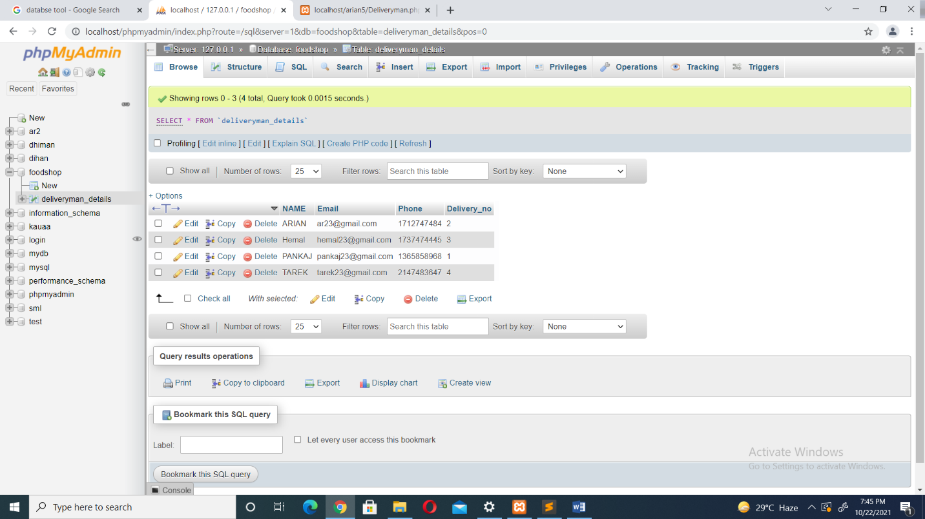

CREATE TABLE FOOD_DETAILS

(

food_item varchar(20),

food_order varchar (20),

order_no int(100),

review varchar(100),

PRIMARY KEY(food_item)

);

INSERT INTO food_details

(food_item,food_order,order_no,review)

VALUES('PIZZA','peparony',2,'This is nice');

|  |  |  |  |
| --- | --- | --- | --- |
| Name | Data type | Allow Nulls | Default |
| food_item(PRIMARY KEY) | varchar(20) |  |  |
| food_order | varchar (20) |  |  |
| order_no | int(100) |  |  |
| review | varchar(100) |  |  |

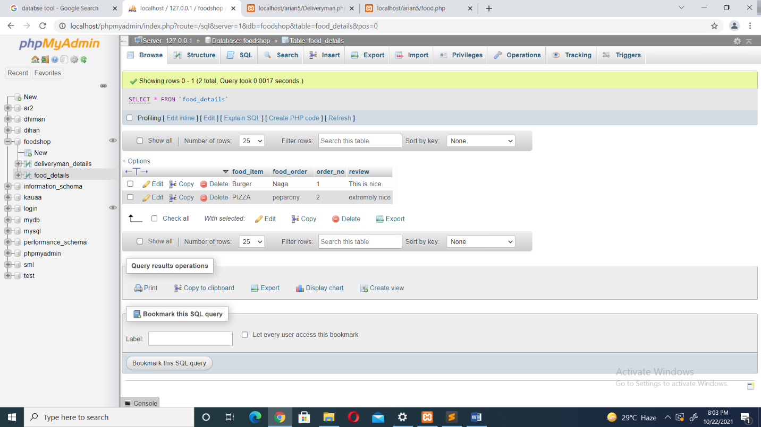

CREATE TABLE CUSTOMER_DETAILS

(

first_name varchar(20),

last_name varchar (20),

phone int(11),

Customer_email varchar(100),

PRIMARY KEY(first_name)

);

INSERT INTO customer_details

(first_name,last_name,phone,Customer_email)

VALUES('ANDRES','INIESTA',01237475856,'iniesta2@gmail.com');

|  |  |  |  |
| --- | --- | --- | --- |
| Name | Data type | Allow nulls | Default |
| first_name(PRIMARY KEY) | varchar(20) |  |  |
| last_name | varchar (20) |  |  |
| phone | int(11) |  |  |
| Customer_email | varchar(100) |  |  |

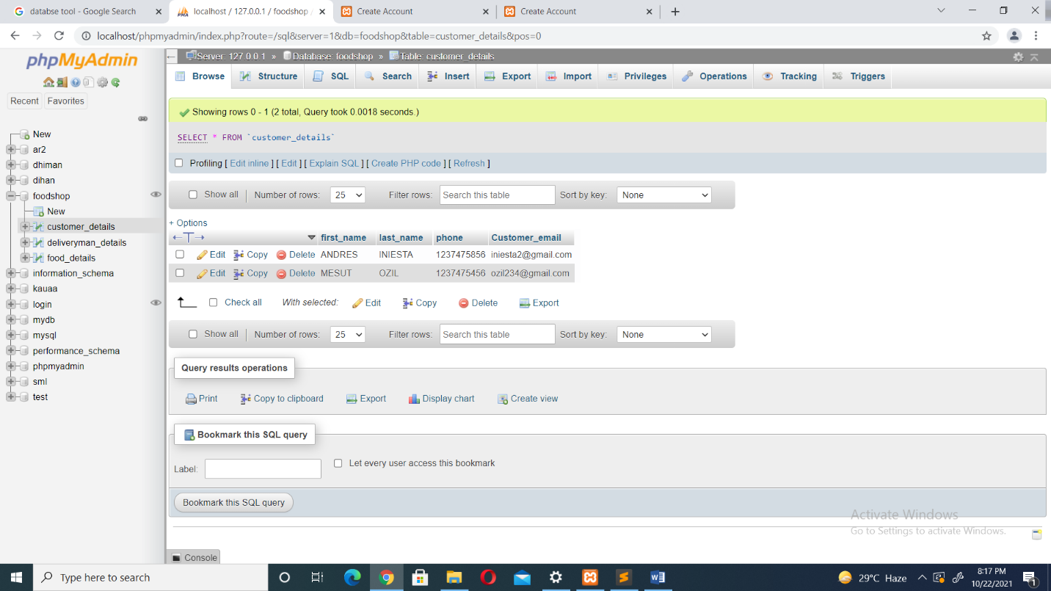

Table name : customer

OnlineFoodShop

First name

sl. - auto increment

Name - varchar

Gender - varchar

Phone - varchar

Email - varchar

Dob - varchar

Uname - varchar

Pass - varchar

Img - varchar

Last name

Gender

Phone

Email

Dob

User name

Password

Image

Admin

Sl. – int

Name - varchar

Id - varchar

Password - varchar

Delivery man

Sl.

Name - varchar

Email - varchar

Phone - varchar

Gender - varchar

Uname - varchar

Pass - varchar

TandC - varchar